MYSQL

* Mysql -uroot -p
  + Used to start up mysql inside of your terminal
* Source
  + By typing source in your terminal followed by the name of the file you are able to just copy and paste the data without having to manually doing it
* Crud operations
  + Create, Read, **Update**, and **Delete**.
  + Read
  + Create
  + Update
  + Insert
  + Inner join
    - Will only merge matching values
  + Left join
  + Right join
    - both left and right join will join from whatever side you choose regardless of a matching value or not
* var mysql = require("mysql");
* var connection = mysql.createConnection({
* host: "localhost",
* // Your port; if not 3306
* port: 3306,
* // Your username
* user: "root",
* // Your password
* password: "",
* database: "ice_creamDB"
* });
* connection.connect(function(err) {
* if (err) throw err;
* console.log("connected as id " + connection.threadId + "\n");
* createProduct();
* });

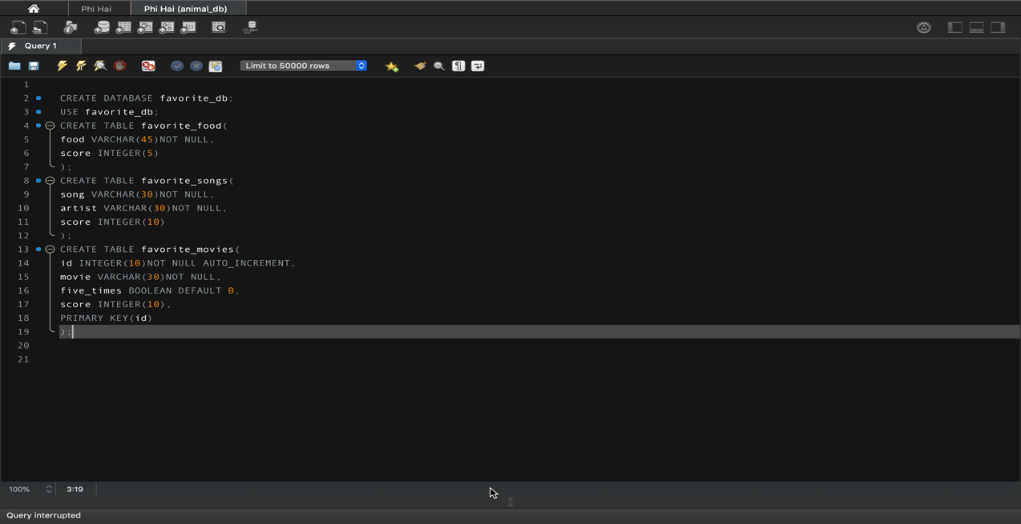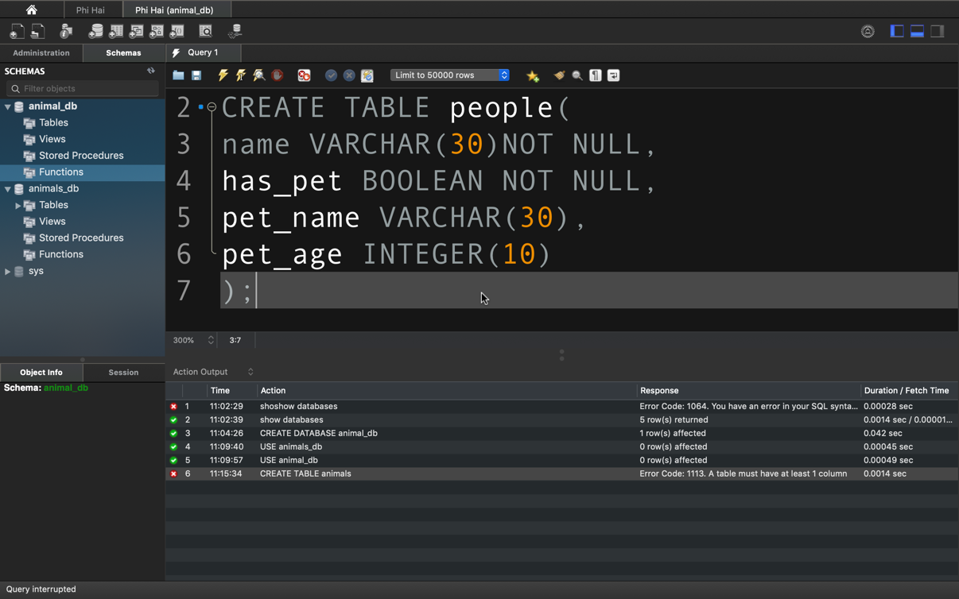

var mysql = require("mysql");

var connection = mysql.createConnection({

host: "localhost",

// Your port; if not 3306

port: 3306,

// Your username

user: "root",

// Your password

password: "password",

database: "top1000Songs_db"

});

connection.connect(function(err) {

if (err) throw err;

console.log("connected as id " + connection.threadId + "\n");

readProducts();

});

function readProducts() {

console.log("Selecting all products...\n");

connection.query(

//search artist by name

"SELECT * FROM top_songs where artist='bing crosby'",

//how to count for record appearing more than once

"SELECT COUNT(artist), artist FROM top5000 GROUP BY artist HAVING COUNT(artist)>1",

//or

"SELECT COUNT(*), artist FROM top5000 GROUP BY artist HAVING COUNT(*)>1",

//returns all data contained within a specific range

"SELECT * FROM top_songs WHERE year>1989 AND year<2000 ORDER BY year asc",

//or you can use the between method

"SELECT * FROM top_songs WHERE year BETWEEN 1989 AND 2000 ORDER BY year asc",

//searches for a specific song in the top song and returns the data for it

"SELECT * FROM top_songs WHERE song='beautiful day'",

function(err, res) {

if (err) throw err;

// Log all results of the SELECT statement

console.table(res);

//loop(res);

})

}

// function loop(object){

// for (const i in object) {

// const element = object[i];

// console.table(element.artist);

// }connection.end();

// }

//how to join data that have same data

SELECT * FROM top_songs INNER JOIN albums ON top_songs.artist = albums.artist AND top_songs.year=albums.year;

